CS-002 Layup Schedule Specification & Recording
Doc ID | CS-002
Title | Layup Schedule Specification & Recording
Revision | F
Status | Draft, pending Lead signature
Effective date | 2026-10-10
Supersedes | Master Tracker "Layup Schedule" shorthand as the only stack record

Approvals
Role | Name | Date
Author | Simon Starbuck (drafted with Claude, SN6 Resources) | 2026-07-12
Reviewer | simon (reviewer agent) | 2026-10-10
Approver (Composites Lead)

Revision history
Rev | Date | Author | Description of change
A | 2026-07-12 | Claude | Initial issue
B | 2026-07-28 | Claude | Language pass: fewer em dashes for rhythm variety, no content change.
C | 2026-08-03 | Claude | §7 gains the coupon suffix convention and the rule that coupon IDs are written on the panel before the first cut (CS-001 §7.6, CS-013 §4.1).
D | 2026-08-28 | Claude | Engineering pass (CS-000 Rev C conventions). Figure 1 draws the §7.3 example stack in section, so "P1 is the mold side" stops being a convention people have to hold in their heads at the cutting table. No rule changed.
E | 2026-08-29 | Claude | Coupons caught up with the app's v4.0.0 R&D bench (CS-013 Rev F): a coupon is CPN-SNx-### under a study that carries the stack and lots, so the filename-to-layup chain now runs through the study record. The write-the-ID-before-the-first-cut rule is unchanged.
F | 2026-10-10 | Claude (doc overhaul, requested by Simon Starbuck) | Caught up with the app's part-and-run model: the plan lives on the part and each run's copy is its as-built record (§5, §9). The freeze is one Stack frozen buy-off whose note names who agreed, and §8 adds a lead check for molds advanced outside a run. Frozen-stack changes, the per-ply check and Materials used are written as the app does them. ME/RE and unmeasured cloth defined; P5 and P6 split; Coupons numbered §7.5 with the study's real fields; the meeting is the weekly meeting. Round 6 fact-check: a run started from a previous run, and a lead's Sign without it on Stack frozen, written in. Register R-002-01..13, R-000-11.

1. Purpose
In SN5 our stacks lived in the tracker as shorthand ("6X 195 + CORE", "195 88 .25 NOMEX"). That's the intent, not what actually got laid. Orientations, core placement, where the copper mesh went, what we substituted when we ran out of cloth: all of it lived in people's heads. That's how the dashboard got remade 3+ times against a spec that existed nowhere (PP-04), how the UT stack was still up in the air three weeks before layup (PP-07), and why nobody could answer "what stack did the seat use last year?" (PP-09). This doc is how we write a stack down before we build, and record what we actually did after.

2. Scope
Every laminated part: infusion, wet layup, foam-wrapped, and forged CF (mass/ratio spec instead of ply table). Applies to R&D coupons too, since untraceable test data is noise.

3. References
Ref | Document | Where
R1 | PP-04, PP-07, PP-09 RCAs | FEB-COMP-PP-001, 01 Pain Points and Improvements/src/pain-points.md
R2 | CS-013 Work Orders (where stacks are recorded) | CS-013
R3 | Rohacell IG-F TDS (core naming example) | 03 Datasheets/ROHACELL_IG_F_2022_April_EN_243534.pdf
R4 | Materials Testing & Recommendation (SN5 coupon data) | SN5 Composites/Documentation/Materials Testing & Recommendation.docx
R5 | The composites app manual: Parts, Work Orders, the R&D bench | 06 Composites App/app/README.md

4. Definitions
- Stack / layup schedule: the full ordered list of plies from mold surface (P1) outward, including cores, meshes, and inserts.
- Orientation: warp direction relative to the part's marked 0° datum. For woven cloth use 0/90 or ±45; for spread-tow/UD state the fiber direction.
- Cloth naming: <gsm> <weave> from the team's stock: 88 spread-tow, 195 twill, 220 twill, 670 twill (Sigmatex); always gsm, never "the thick one". A cloth whose gsm has not been measured yet is written by type and source until it is, for example UD carbon, ACP, gsm TBD. Measuring it is a task to assign, not a footnote.
- Inserts: a G10 (or other) insert is a ply in the table like a core, with its material and thickness written in the row. A thickness mismatch between an insert and the core around it is a deviation to record (§7.4).
- ME / RE: the part's Mold Engineer (ME) and Manufacturing Engineer (RE), the two engineer fields on the part and on each of its runs. Both are picked from the app's roster, not typed (CS-013 §4).
- Plan and as-built: the plan is the stack on the part (Parts tab, Layup stack). The as-built is the copy each run takes when it is started (from the plan, or from a previous run if chosen), kept in the run's Stack & BOM section. Editing the run's copy never changes the plan.
- Stack freeze: the buy-off of the Stack frozen step on a run (§7.2). From then on, edits to the part's plan no longer reach that run, and the run's stack changes only as §7.2 steps 3 to 6 say.

5. Equipment & Materials
None; this is a specification standard. The planned stack lives on the part (Parts tab, Layup stack section, R5). Each run (work order) gets a copy when it is started with + New run, and that copy becomes the run's as-built record in its Stack & BOM section (CS-013 §7.1, §7.2). On a part that already has runs, + New run asks for a Starting point: Start fresh copies the plan; Use a previous run can copy that run's Layup stack as laid and BOM instead, and the new run then starts as as-built.

6. Safety
No physical hazards; specification standard. Shop-floor safety lives in the process standards it feeds (CS-006, CS-007).

7. Procedure

7.1 Specify (before any manufacturing)
- The part's Manufacturing Engineer (RE) drafts the stack on the part: Parts tab, Layup stack, + ply, one row per ply from the mold surface outward, in the format of §7.3.
- Justify the choice in one or two lines per decision: coupon data (R4), the SN5 as-built for a similar part (its WO), or an explicit assumption flagged for testing. New unproven stacks on schedule-critical parts require a coupon or test panel first.
- Include function plies explicitly: sacrificial 88 spread-tow outer layers for sanding protection, copper mesh position and overlap for grounded parts (CS-010), core chamfers/grooves.
- State the target: cured thickness (mm), mass (g), and any acceptance measurement (e.g. grounding Ω per CS-010).

7.2 Freeze
- The stack freezes before mold machining starts. Mold geometry (offsets, flange height) can depend on stack thickness, and machine slots are too scarce to cut twice (PP-03, PP-06). For mold-less flat panels, freeze before cloth is cut. Inside a run the app holds this order: Stack frozen is a blocker ahead of the mold steps. A mold advanced on the Molds tab or from the cut list is not checked against it, so the lead checks those at the weekly meeting (§8).
- The freeze is the buy-off of the Stack frozen step on the run. Before signing, the signer shall have agreed the stack with the RE and the Composites Lead (plus the requesting subteam's lead for cross-team parts, the dashboard lesson, PP-04), and shall name them in the step's note. The app refuses a member's signature while the run has no plies; a lead can sign without it (Sign without it), with the reason logged in the work order's event log. The note naming who agreed is this standard's requirement, not the app's.
- Every stack-freeze date appears as a deadline in the Schedule tab, reviewed at the weekly meeting (PP-07). A frozen stack changes only by a run revision (steps 4 to 6): quick to do, but visible and counted.
- Edit the run's stack in Stack & BOM. The run then shows how many plies differ from the part's plan.
- Raise the run's Revision by one letter in its Details, and write why in the run's Notes.
- If future runs should follow the change, press Compare on the run's stack, then Adopt as the part's plan.

7.3 Ply table format
Ply | Material | Orientation | Coverage | Notes
P1 (mold side) | 88 spread-tow | 0/90 | full | sacrificial/finish
P2 | 195 twill | ±45 | full
P3 | Cu mesh | n/a | zones A–B | grounding, 25 mm overlap onto P2
P4 | Rohacell 31 IG-F 3 mm | n/a | core zone | chamfer 20°, grooves per CS-006
P5 | 195 twill | 0/90 | full
P6 | 195 twill | ±45 | full
P7 (bag side) | 88 spread-tow | 0/90 | full

(Example only: the table above is the format, not a recommended stack.)
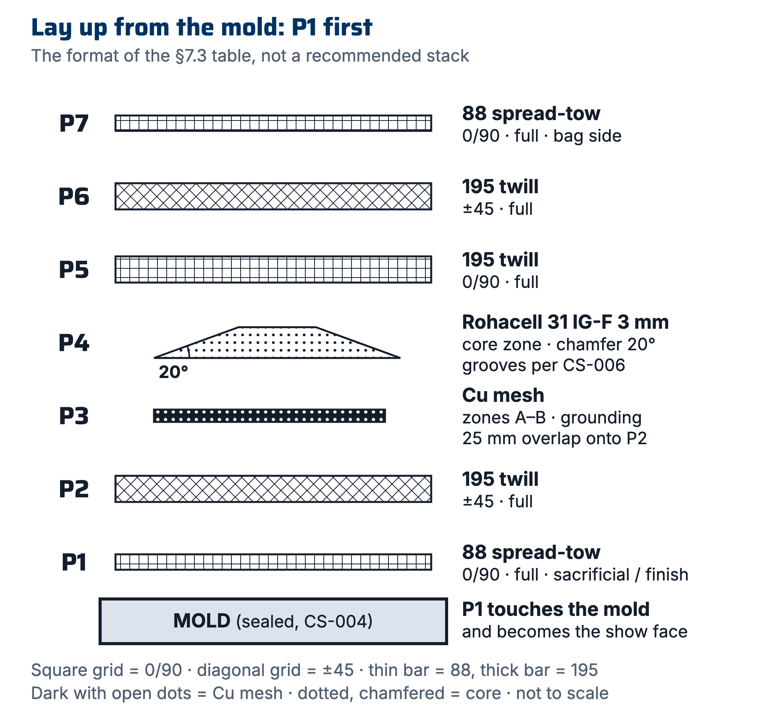
Figure 1. The §7.3 example stack drawn in section. P1 touches the mold and becomes the show face; function plies are drawn, and specified, explicitly.

7.4 Record as-built (during/after layup)
- During layup, the RE checks each ply against the run's stack in Stack & BOM. Any change (substituted cloth, extra ply, mesh moved) is edited into the run's stack row by row, with the reason in that ply's Notes cell. The RE may also tick each ply in pen on the printed traveler. No deviation is too small to note: "we were out of 195 so used 220" is exactly the data that explains a mass or thickness surprise later.
- Photograph the stack at: cores/mesh placed, and bagged-before-infusion. Photos attach to the WO steps.
- After cure, record actual mass and thickness next to targets in the run's Quality section.
- At the buy-off that starts the cure (Infuse, Wet layup and bag or Wet layup over core), confirm or correct Materials used for each BOM line. The app prefills each line from the plan; a blank means not measured, and stays that way in the record.
- If this run proved a BOM line of the plan wrong, press ↩ plan on that line, so the next run starts from what this one learned. The button shows once a line's used quantity differs from the plan.
- If this run proved the plan's stack wrong, press Compare on the run's stack, then Adopt as the part's plan.
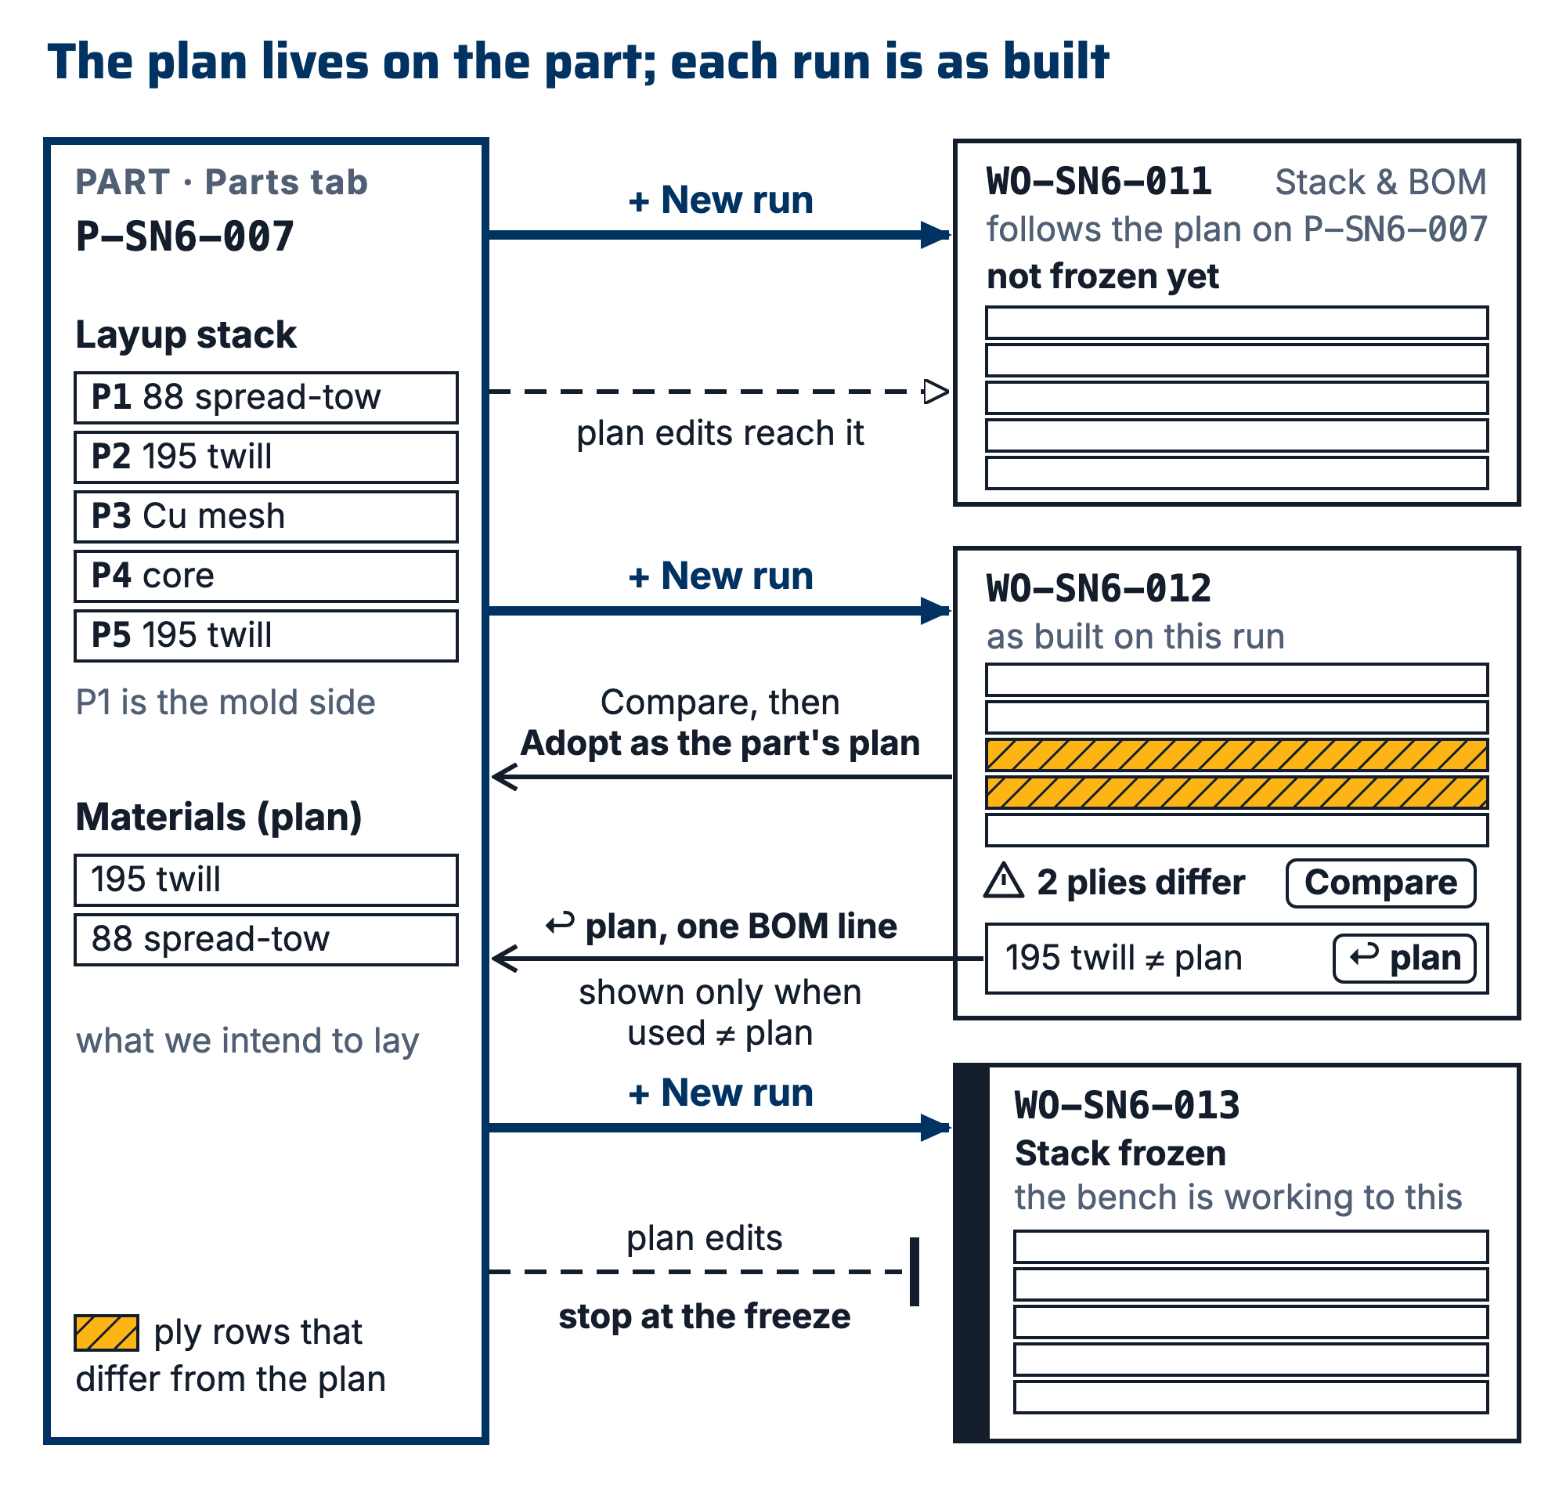
Figure 2. Plan and as-built: the part's Layup stack and Materials (plan) are copied into each run at + New run (or a previous run's are, if chosen); the run's edits make it as-built with a count of plies that differ; Adopt as the part's plan and ↩ plan carry a run's changes back; Stack frozen stops later plan edits reaching the run.

7.5 Coupons: IDs and data files
A coupon is CPN-SNx-###: its own record on the app's R&D bench, belonging to a study RDS-SNx-### (CS-013 §4.1). The study's Materials carry the Layup stack (as text, in the §7.3 order from P1 outward, or the ID of the run whose panel the coupons were cut from), the Fabric lot, Resin lot and Hardener lot, the Lot record, Laid up on and Laid up by. Every coupon inherits them. A coupon that was different says so in its own row, and clearing that cell hands it back to the study. That inheritance is what makes one coupon ID enough to recover the whole build. (The retired suffix spelling PNL-SNx-###-Cnn survives only on frozen SN5-era records.)
- Write every coupon ID on the panel before the first cut, across the cut lines, so each piece inherits a legible fragment. After the saw there is no way to recover which piece was which.
- Name the raw data file after the coupon: CPN-SN6-042.csv. That one filename then carries the study, the stack, the session and the material lots, through one link each, none of them retyped.
⚠ CAUTION: This is written against a real failure. The SN5 tensile set is seventeen CSVs named TensileTesting_12_8_2025_<n>.csv whose contents are Time, Displacement and Force with no header block and no specimen identity of any kind. The mapping from specimen to layup exists only in a Word table that contradicts itself. Untraceable test data is noise (§2).

8. Quality checks / acceptance criteria
Check | Target | Method | Record where
Stack frozen before mold machining / cloth cut | Stack frozen signed, its note naming who agreed | Run blocker step in the app; for any mold advanced on the Molds tab or the cut list, lead check at the weekly meeting that its run shows Stack frozen signed (neither checks it) | Run (Stack frozen step)
As-built matches frozen stack | Any deviation noted, none silent | RE self-check + photo review | Run's Stack & BOM
Mass vs target | Within stated tolerance (default ±10%, team value) | Scale | The run's Quality section
Thickness vs target | Within stated tolerance | Calipers at 3+ points | The run's Quality section

9. Records
The part's plan (Layup stack and Materials (plan)), each run's as-built stack and materials used with its deviations, and the step photos together are the permanent record. The Master-Tracker-style shorthand may still be used in dashboards/summaries, but it is a view of those records, never the source of truth.

